ThreadGroup类

# ThreadGroup

## package

public class ThreadGroup extends **Object** implements **Thread.UncaughtExceptionHandler**

ThreadGroup类存在于java.lang包中，直接继承于Object类，实现了Thread.UncaughtExceptionHandler接口。

## 功能

A thread group represents **a set of threads**. In addition, a thread group can also include other thread groups. The thread groups **form a tree** in which every thread group except the initial thread group has a parent.

一个线程组中包含了许多线程，同时也可以包括其他线程组，线程组之间构成树状结构，每一个线程组都可以有个父线程组（初始化线程组除外）。

A thread is allowed to access information about its own thread group, but not to access information about its thread group's parent thread group or any other thread groups.

## 构造方法

### ThreadGroup(String name)：创建一个名字为name的线程组。

Constructs a new thread group.

### ThreadGroup(**ThreadGroup parent**, String name) ：创建一个父线程组为parent、名字为name的线程组。

Creates a new thread group.

## 方法介绍

### activeCount()：该线程组中即子线程组中**存活线程**的数目。

int activeCount()

Returns an estimate of the number of active threads in this thread group and its subgroups.

### activeGroupCount()：该线程组中即子线程组中**存活线程组**的数目

int activeGroupCount()

Returns an estimate of the number of **active groups** in this thread group and its subgroups.

### void **checkAccess**()：判断当前线程组是否能够修改该线程组.

void checkAccess()

Determines if the currently running thread has permission to modify this thread group.

### destroy():销毁当前线程组及所有的子线程组。

void destroy()

Destroys this thread group and all of its subgroups.

### enumerate(Thread[] list)：拷贝当前线程组中存活线程到Thread数组list中。

enumerate(ThreadGroup[] list)

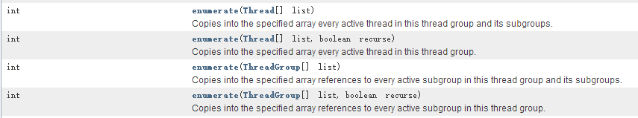

### 其他方法

